P.sharath chandrareddy

192111582

1. Develop a system using UML for

Passport Management System; it should verify the passport details of the applicant by the central computer.

The details regarding the passport will be provided to the central computer and the computer will verify the details of the applicant and provide approval to the office. Then the passport will issue from the office to the applicant.

ACTIVITY DIAGRAM:

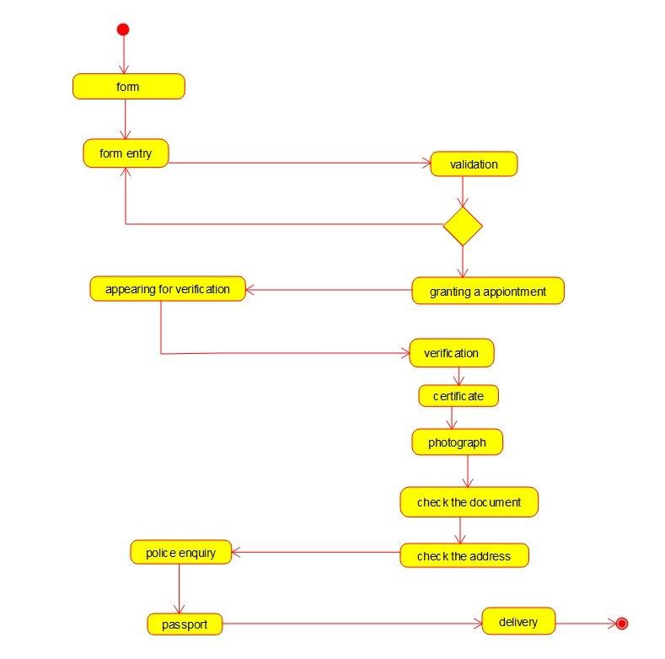

USE CASE DIAGRAM:

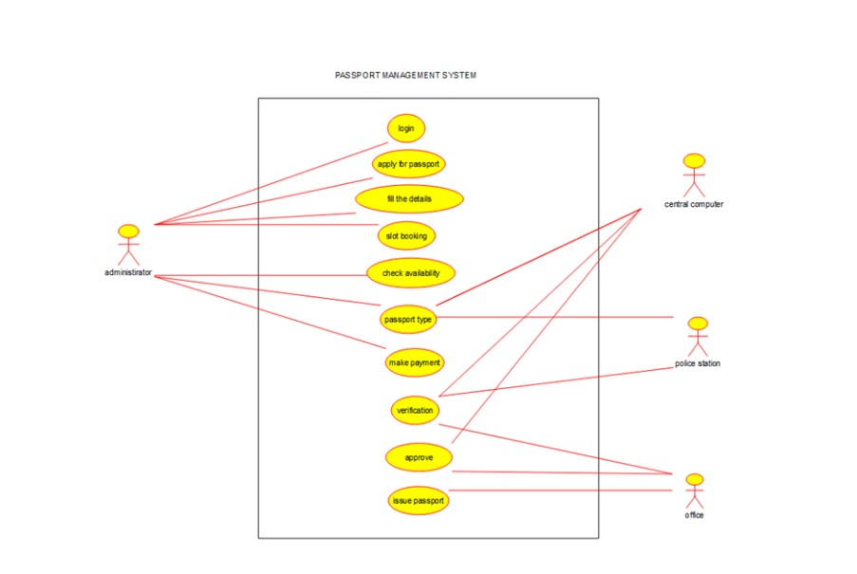

CLASS DIAGRAM:

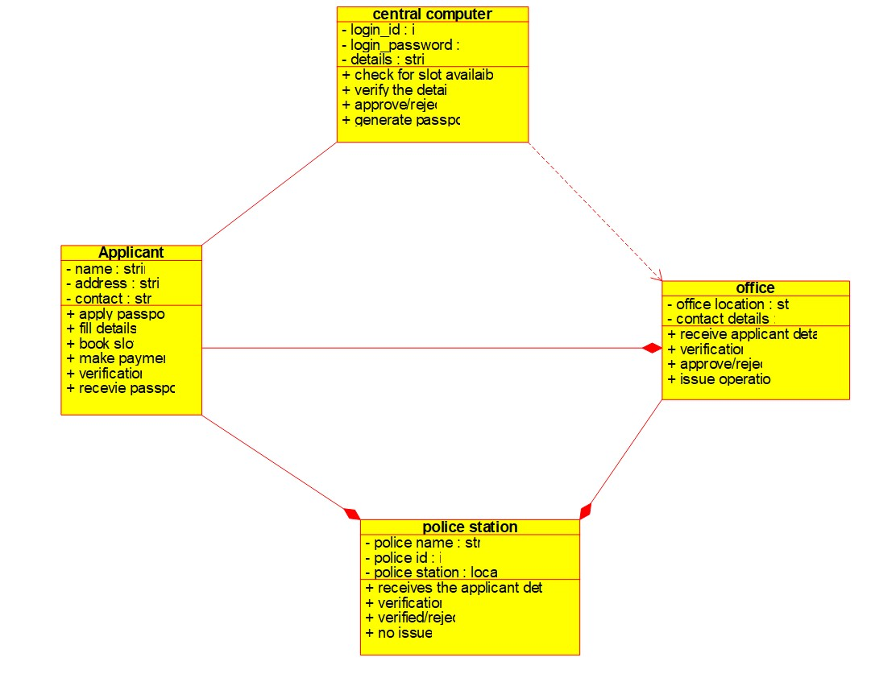

1. Develop a system using UML for implementing the Book Bank process.

It should verify the details of

the student by the central computer. The details regarding the student will be

provided to the central computer

through the administrator in the book bank and the computer will verify the details of the student and provide

approval to the office. Then the books that are needed by the student will issue from the office to

him.

CLASS DIAGRAM:

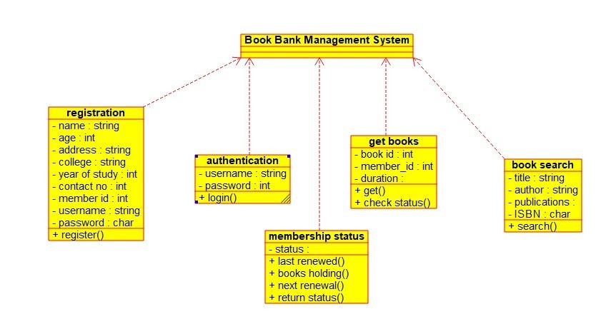

USE CASE DIAGRAM:

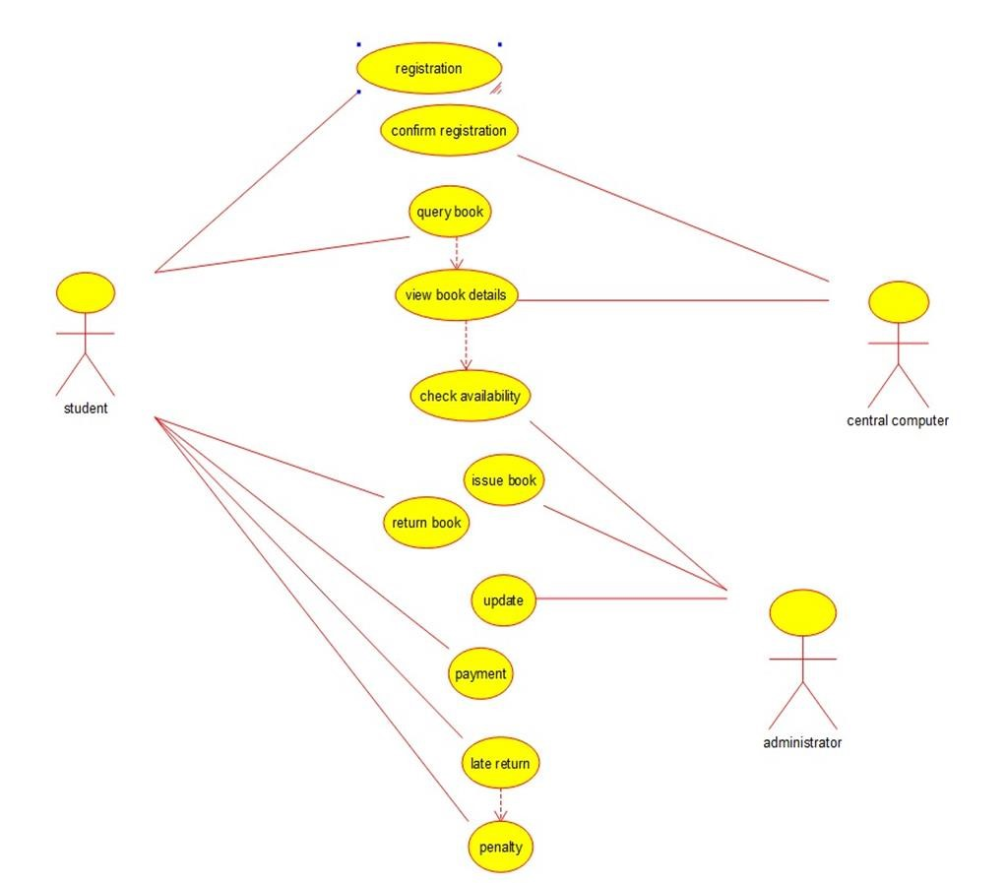

ACTIVITY DIAGRAM:

